**SQL**

What is SQL?

* SQL stands for Structured query language.
* which is a computer language for storing, manipulating, and retrieving data stored in a relational database.
* SQL is the standard language for Relational Database System. All the Relational Database Management Systems (RDMS) like MySQL, MS Access, Oracle, Sybase, Informix, Postgres, and SQL Server use SQL as their standard database language.

Why SQL?

SQL is widely popular because it offers the following advantages:

• Allows users to access data in the relational database management systems.

• Allows users to describe the data.

• Allows users to define the data in a database and manipulate that data.

• Allows to embed within other languages using SQL modules, libraries & pre-compilers.

• Allows users to create and drop databases and tables.

• Allows users to create view, stored procedure, functions in a database.

• Allows users to set permissions on tables, procedures, and views.

SQL Commands

SQL Commands are instructions.it is used to communicate with the database.it is also used to perform specific tasks, functions, and queries of data.

1.Data Definition language (DDL)

The DDL is used to create an object (e.g., table) and also to drop the object created.

**Table Definition:**

A table is a unit of storage which holds data in the forms of rows and columns.

The DDL for table definition can be classified into the following four categories.

1. Create table command

2. Alter table command

3. Drop table command

**1.The create table command:**

**a. Creating table:**

**Syntax:**

Create table tablename(column_name datatype(size), column_name datatype(size)…

);

**Example:**

Create table student(name varchar(10),regno int(6));

If the above statement is successfully executed, then the message

“ Table created” will be displayed.

**Note:**

􀀀 While naming a table the first letter should be an alphabet.

􀀀 Mysql reserved word cannot be used to name the table.

􀀀 Maximum length for the table name is 30 characters.

􀀀 Two different tables should not have the same name.

􀀀 Specification of column name must be unique.

􀀀 Datatype along with width must be specified.

􀀀 Not null constraint can be included, if the specified column should not empty.

**2. Modifying the structure of the table:**

**a. Adding new columns:**

**Syntax:**

Alter table tablename add(column_name datatype(size),column_name datatype(size));

**Example:**

Alter table student add(year varchar(3), DOB date);

**b. Modifying existing column:**

**Syntax:**

Alter table tablename modify column_name datatype(size);

**Example:**

Alter table student modify column name varchar(15);

If the above statement is successfully executed then the message “ Table altered

“ will be displayed.

**c. Drop Column from an Existing table:**

**Syntax:**

Alter table tablename DROP COLUMN column_name;

**Example:**

ALTER TABLE student DROP COLUMN rollno;

**3. The Drop table command:**

**a. Drop table**

**Syntax:**

Drop table tablename:

**Example:**

Drop table student;

If this statement is successfully executed then the message “ Table dropped

“ will be displayed.

**b. Truncate a table:**

**Syntax:**

Truncate table tablename;

**Example:**

Truncate table student;

Implementation of this command will delete all rows associated with the table, only

the structure of the table remains.

**c. Describe Table**

If the user wants to view the structure of the table, the following command helps to

achieve the same.

**Syntax:**

Desc tablename;

**Example:**

Desc student;

**DML:**

Data Manipulation Language commands are the most frequently used SQL

commands to modify the data in the database objects and they are as follows:

Insert

Select

Update

Delete

**1. Insert Command:**

The insert command is used to add one or more rows to a table. While using this

command the values are separated by commas and the datatypes char and date are

enclosed in

**a. Inserting a single row of data into a table:**

**Syntax:**

Insert into <tablename> values(list of data values);

**Example:**

Insert into order_info values(123,” 1980-02-23” ,’ b’ );

If the user to skip any one of the fields then he can enter null against that columns

value. In the previous example null been inserted for the column total.

**b. Inserting more than one record using a single insert command:**

**Syntax:**

**Example:** Insert into <tablename> (col1,col2… .)values(list of data values),( list of data values);

Insert into student (rollno,name)values(101,’ john’ ),(102,’ paul’ );

**2. Select command:**

**a. Global data extract:**

To perform a query we use a select command. The query is the request for information.

It is the most common database operation used. We can either display all columns in

a table or only specify column from the table.

**Syntax:**

Select * from <tablename>;

**Example:**

Select * from student;

**c. The retrieval of specific column from a table:**

**Syntax:**

Select col1,col2,… from <tablename>;

**Example:**

Select name, rollno from student;

**d. Elimination of duplicates from the select statement:**

**Syntax:**

Select DISTINCT col1,col2 from <tablename>;

**Example:**

Select DISTINCT rollno from student;

**3. Update command:**

Update command is used to alter the column values in a table. The update command

consists of a set clause and a optional ‘ where’ clause. The where clause and the

set clause can also include queries. Update sets each fields with the value that we

supply provided it satisfies the where condition.

**Syntax:**

new-, field2 = new- value1 UPDATE table_name SET field1 = value2 [WHERE Clause]

**Example:**

Update item set actprice=100 where proid=11;

Update student set name=’ Robert’ where rollno=200;

**4. Delete command:**

After inserting row in a table, we can also delete them if required. The delete

command consists of a from clause followed by an optional where clause.

DELETE FROM student WHERE rollno=200;

**Uses of DCL:**

* It is used in order to control various operations of the database objects.
* Two commands are supported by this language.
* Grant
* Revoke
* **Grant**: This command is used to grant permission on database objects from one user to another user.
* **Revoke**: This command is used to cancel the given permission

MySQL server provides multiple types of privileges to a new user account. Some of the most used privileges are given below:

1. **ALL PRIVILEGES:** It permits all privileges to a new user account.
2. **CREATE:** It enables the user account to create databases and tables.
3. **DROP:** It enables the user account to drop databases and tables.
4. **DELETE:** It enables the user account to delete rows from a specific table.
5. **INSERT:** It enables the user account to insert rows into a specific table.
6. **SELECT:** It enables the user account to read a database.
7. **UPDATE:** It enables the user account to update table rows.

**Syntax:**

Grant <Permission List> on <table name> to <Users List>

Eg: Grant select, insert on students to kero;

**GRANT** ALL **PRIVILEGES** **ON** table name **TO** username;

Sometimes, you want to **flush** all the privileges of a user account for changes occurs immediately, type the following command.

FLUSH **PRIVILEGES**;

If you want to see the existing privileges for the user, execute the following command.

mysql> SHOW GRANTS **for** username;

**Revoke:** This command is used to Cancel given permission

Syntax: Revoke <Pemission list> on <table name> from <user list>;

Eg: Revoke select, insert on student from user2;

**Step 1 : Entering into Root:**

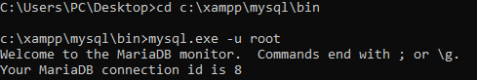

**Step 2: Create database:**



**Step 3: Using database:**

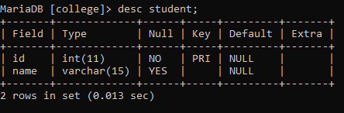

**Step 4: Create table and description of table:**

**Step 5: Inserting records into table:**



**Step 6: Using Select Command, displaying the entire records of the table:**

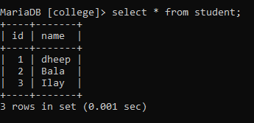

**Step 7: Create User:**

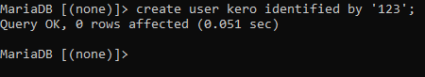

**Step 8: Command to see the total number of users created:**

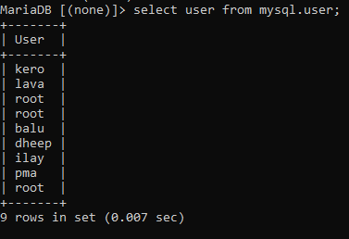

**Step 9: GRANT Permission to access the table with SELECT, INSERT AND UPDATE command:**



**Step 10: Exit out from root:**



**Step 1: Now enter into newly created User:**

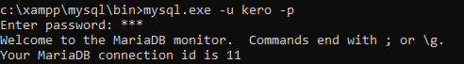

**Step 2: Use the database for inserting, updating, and selecting the tables:**

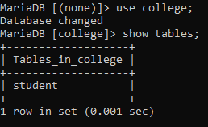

**Step 3: Check for the permission of the tables (INSERT, UPDATE, SELECT):**

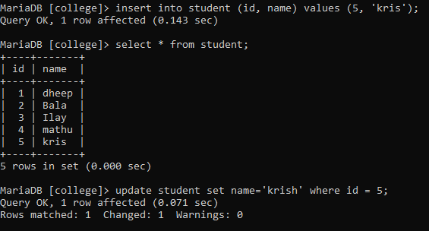

**Step 4: Other Commands like DELETE, ALTER etc will not work, because the GRANT permission is not allowed these commands:**



**Step 5: Exit out from root:**

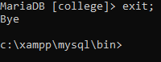

**Step 1: Again Log into root to REVOKE the permissions:**



**Step 2: Use the database to REVOKE permission:**

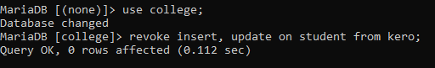

**Step 3: Exit from root and Log into user to check for permissions:**

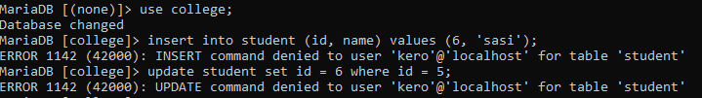

**Step 1: Only the select will work, because its Grant is not revoked:**

